**Web Application Requirements**

Team members: Monil Suthar, Xiangpeng Li

Group #: 4

**Description:**

Roommate Karma is a roommate rating application that aimming at students to find suitable roommates and also help themselves be better roommates. It will recommend users their ideal roommates based on their profiles. Also it rates users by and others’ evaluations and chores they have completed(such as doing the laundry, taking out the trash and sweeping the floors). Once they get high enough scores, they can offer bounty to their roommates who are willing to do the job. So in that way users can be moviated to be better roommates.

**Purpose:**

Roommates are not the only the ones who are sharing the bathroom and kitchen with us for some certain time, they can also our life-time friends and studying partners. We are building this application to solve the problem that people don’t know enough about their roommates before they decide to rent a house together. This application provide a convenient way for users to find their ideal roommates.

**Marketing:**

We first advertise it among our friends who have interests in sharing rooms, then we will post our web link on forums which have more users between 18 and 25 (Reddit, Facebook and Instagram).

**Target Audience:**

People who are planning to share rooms with others. Mostly students or working professionals who are not living with their family.

**Competition / Examples:**

N/A. This idea is relatively unique amongst other subletting apps and other roommate hunting apps.

**Technical Requirements:**

1. Server type: Apache

2. Hypervizor: VirtualBox

3. Web Server: Apache

4. Database: MySQL

5. Scripting Language: PHP

6. Support Libraries: Mcrypt, others to be added later

7. Framework: Laravel, Bootstrap

8. Access to server: Git

9. Access to database:

10. Security / Authentication: Using 3rd party library (Sentinel)

**Sitemap:**

For the front end side we will use Bootstrap framework to build a responsive website. Every page share the same template. On the left side of the home page, there are different entries such as Live Ranking, Achievement, Reward Tasks, and Find On Map. When we click on these entries, the content will be displayed at the center of the page while remaining others unchanged. There will be a navigation bar at the top of page, it will provide the functionalities like Notifications, Login and Search Box.

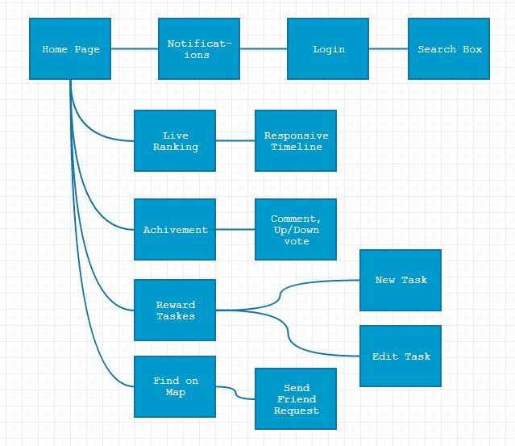

**Application Architecture:**

We will use Laravel as the basic framework. For the front end side we choose to use Bootstrap to create responsive page, for the back end side, we use MySQL, because Laravel provide us a convenient way to modify Sql database (Model).

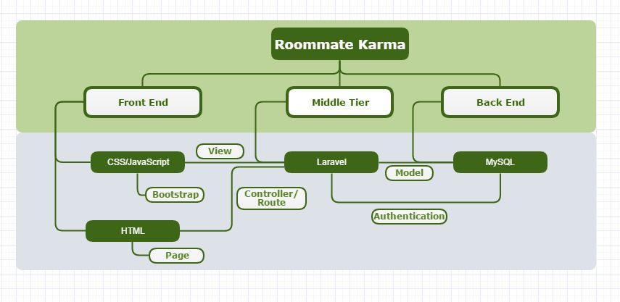

**Database Design:**

